1. **Experiment 3: TurtleSim Programming, Publisher, Subscriber, Services, Actions**

Recap:

Setup for launch files:

* Create a new package
* Create a launch/ folder at the root of the package.
* Configure CMakeLists.txt to install files from this launch/ folder.
* Create any number of files you want inside the launch/ folder, ending with .launch.py.

Run a launch file:

* use “colcon build” to install the file.
* source your environment
* launch file with “ros2 launch <package> <name_of_the_file>

First try to design the application by yourself. Don’t write code! Just take a piece of paper and make the design. What nodes should you create? How do the nodes communicate between each other? Which functionality should you add, and where to put them? Etc.

* Directly start on your own (Use the template to start with)
* Work step by step on each functionality/communication.

**Client – Server Nodes**

**Execute in Terminal #1**

ros2 interface show example_interfaces/srv/AddTwoInts

**Execute in Terminal #1**

cd ros2_ws/src/my_package/my_package

touch add_two_ints_server.py

chmod +x add_two_ints_server.py

Edit add_two_ints_server.py in visual studio editor

#!/usr/bin/env python3

import rclpy

from rclpy.node import Node

from example_interfaces.srv import AddTwoInts

class AddTwoIntsServerNode(Node):

def __init__(self):

super().__init__("add_two_ints_server")

self.server_ = self.create_service(AddTwoInts, "add_two_ints", self.callback_add_two_ints)

self.get_logger().info("Add two ints server has been started")

def callback_add_two_ints(self, request, response):

response.sum = request.a + request.b

self.get_logger().info(str(request.a)+ " + " + str(request.b) + " = " + str(response.sum))

return response

def main(args=None):

rclpy.init(args=args)

node = AddTwoIntsServerNode()

rclpy.spin(node)

rclpy.shutdown()

if __name__ == "__main__":

main()

**Add executable name in setup.py**

entry_points={

'console_scripts': [

'sample = my_package.sample:main',

'robot_publisher = my_package.robot_publisher:main',

'robot_subscriber = my_package.robot_subscriber:main',

'add_two_ints_server = my_package.add_two_ints_server:main'

],

**Execute in Terminal #1**

colcon build –packages-select my_package

**Execute in Terminal #2**

ros2 run my_package add_two_ints_server

**Execute in Terminal #3**

ros2 service call /add_two_ints example_interfaces/srv/AddTwoInts "{a: 3, b: 4}"

Ctrl + C in all terminal windows.

**Execute in Terminal #1**

cd ros2_ws/src/my_package/my_package/

touch add_two_ints_client.py

chmod +x add_two_ints_client.py

Edit add_two_ints_client.py using visual studio editor

#!/usr/bin/env python3

import rclpy

from rclpy.node import Node

from example_interfaces.srv import AddTwoInts

from functools import partial

class AddTwoIntClientNode(Node):

def __init__(self):

super().__init__("add_two_ints_client")

self.call_add_two_int_server(6, 7)

def call_add_two_int_server(self, a, b):

client = self.create_client(AddTwoInts, "add_two_ints")

while not client.wait_for_service(1.0):

self.get_logger().warn("Waiting for Server Add Two Ints")

request = AddTwoInts.Request()

request.a = a

request.b = b

future = client.call_async(request)

future.add_done_callback(

partial(self.callback_call_two_ints, a=a, b=b))

def callback_call_two_ints(self, future, a, b):

try:

response = future.result()

self.get_logger().info(str(a) + " + " + str(b) + " = " + str(response.sum))

except Exception as e:

self.get_logger().error("Service call failed %r" % (e,))

def main(args=None):

rclpy.init(args=args)

node = AddTwoIntClientNode()

rclpy.spin(node)

rclpy.shutdown()

if __name__ == "__main__":

main()

**Add executable name in setup.py**

entry_points={

'sample = my_package.sample:main',

'robot_publisher = my_package.robot_publisher:main',

'robot_subscriber = my_package.robot_subscriber:main',

'add_two_ints_server = my_package.add_two_ints_server:main',

'add_two_ints_client = my_package.add_two_ints_client:main'

],

**Execute in Terminal #1**

colcon build --packages-select my_package –symlink-install

**Execute in Terminal #2**

ros2 run my_package add_two_int_server

**Execute in Terminal #3**

ros2 run my_package add_two_ints_client

**Execute in Terminal #4**

ros2 node list

**Execute in Terminal #5**

ros2 service list

ros2 service type /add_two_ints

ros2 interface show example_interfaces/srv/AddTwoInts

ros2 service call /add_two_int example_interfaces/srv/AddTwoInts

ros2 service call /add_two_int example_interfaces/srv/AddTwoInts "{a: 3, b: 4}"

rqt

plugins→services→service caller

service - /add_two_ints

Enter the values under Expression for a and b

Click call

**Response is viewed in the second window**

**Exercise 1: Create a service-client operation to reset the counter value in the number_counter nodes.**

The node “number_publisher” publishes a number on the /”number” topic.

The node “number_counter” gets the number, adds it to a counter, and publishes the counter on the “/number_count” topic.

Add the following ros2 services

Add a functionality to reset the counter to zero:

* Create a service server inside the “number_counter” node.
* Service name: “/reset_counter”
* Service type: example_interfaces/srv/SetBool. Use “ros2 interface show” to discover what’s inside!
* When the server is called, you check the boolean data from the request. If true, you set the counter variable to 0.

We will then call the service directly from the command line. You can also decide - for more practice - to create your own custom node to call this “/reset_counter” service.

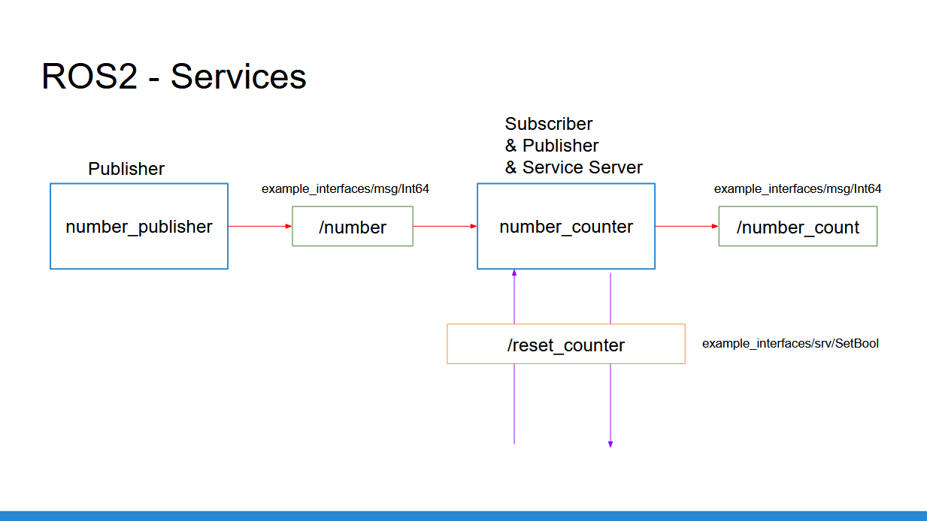

Add a functionality to reset the counter to zero:

* Create a service server inside the “number_counter” node.
* Service name: “/reset_counter”
* Service type: example_interfaces/srv/SetBool. Use “ros2 interface show” to discover what’s inside!
* When the server is called, you check the boolean data from the request. If true, you set the counter variable to 0.

We will then call the service directly from the command line. You can also decide - for more practice - to create your own custom node to call this “/reset_counter” service.

#!/usr/bin/env python3

import rclpy

from rclpy.node import Node

from example_interfaces.msg import Int64

from example_interfaces.srv import SetBool

class NumberCounterNode(Node):

def __init__(self):

super().__init__("number_counter")

self.counter_ = 0

self.number_count_publisher_ = self.create_publisher(Int64, "number_count", 10)

self.number_subscriber_ = self.create_subscription(Int64, "number", self.callback_number, 10)

self.reset_counter_service_ = self.create_service(SetBool, "reset_counter", self.callback_reset_counter)

self.get_logger().info("Node started")

def callback_number(self, msg):

self.counter_ += msg.data

new_msg = Int64()

new_msg.data = self.counter_

self.number_count_publisher_.publish(new_msg)

self.get_logger().info(str(self.counter_))

def callback_reset_counter(self, request, response):

if request.data:

self.counter_ = 0

response.success = True

response.message = "Counter is reset"

else:

response.success = False

response.message = "Counter is not reset"

return response

def main(args=None):

rclpy.init(args=args)

node = NumberCounterNode()

rclpy.spin(node)

rclpy.shutdown()

if __name__ == "__main__":

main()

**Execute in Terminal #1**

ros2 interface show example_interfaces/srv/SetBool

**Execute in Terminal #1**

cd ros2_ws/

colcon build --packages-select my_package

**Execute in Terminal #1**

ros2 run my_package number_publisher

**Execute in Terminal #2**

ros2 run my_package number_counter

**Execute in Terminal #3**

ros2 topic list

ros2 topic echo /number_count

**Execute in Terminal #4**

ros2 service call /reset_counter example_interfaces/srv/SetBool "{data: False}"

ros2 service call /reset_counter example_interfaces/srv/SetBool "{data: True}"

**Custom Services**

cd ros2_ws/src/my_robot_interface

mkdir srv

cd srv

touch SetDate.srv

SetDate.srv

string robot_name

int64 date

---

bool success

Change CmakeLists.txt as

rosidl_generate_interfaces(my_robot_interface

"msg/ManufactureDate.msg"

"srv/SetDate.srv"

)

colcon build –packages-select my_robot_interface

Change robot_publisher.py code as

#!/usr/bin/env python3

import rclpy

from rclpy.node import Node

from my_robot_interface.msg import ManufactureDate

from my_robot_interface.srv import SetDate

class RobotDatePublisher(Node):

def __init__(self):

super().__init__("robot_date_publisher")

self.robot_name_="ROBOT"

self.publisher_ = self.create_publisher(ManufactureDate, "robot_manufacturing_date", 10)

self.timer_ = self.create_timer(0.5, self.publish_news)

self.set_date_ = self.create_service(SetDate, "set_date", self.callback_set_date)

self.get_logger().info("Node Started")

def callback_set_date(self, request, response):

name = request.robot_name

date = request.date

if (name =="ROBOT") and (date==12):

response.success = True

else:

response.success = False

return response

def publish_news(self):

msg = ManufactureDate()

msg.date = 12

msg.month = "March"

msg.year = 2022

self.publisher_.publish(msg)

def main(args=None):

rclpy.init(args=args)

node = RobotDatePublisher()

rclpy.spin(node)

rclpy.shutdown()

if __name__ == '__main__':

main()

**Execute in Terminal #1**

colcon build –packages-select my_package

**Execute in Terminal #1**

ros2 run my_package robot_publisher

**Execute in Terminal #2**

ros2 service list

ros2 service call /set_date my_robot_interface/srv/SetDate "{name: "ROBOT", date: 12}"

change robot_subscriber.py code as

#!/usr/bin/env python3

import rclpy

from rclpy.node import Node

from example_interfaces.msg import String, Int32

from my_robot_interface.msg import ManufactureDate

from my_robot_interface.srv import SetDate

from functools import partial

class RobotDateSubscriber(Node):

def __init__(self):

super().__init__("robot_date_subscriber")

self.subscriber_ = self.create_subscription(ManufactureDate, "robot_manufacturing_date", self.callback_robot_news, 10)

self.get_logger().info("robot_subscriber Node Started")

def callback_robot_news(self, msg):

information ="Manufacturing Date of the ROBOT is " + str(msg.date) + " " + str(msg.month) + " " + str(msg.year)

self.get_logger().info(information)

self.check_date_server("ROBOT", 12)

def check_date_server(self, robot_name, date):

client = self.create_client(SetDate, "set_date")

while not client.wait_for_service(1.0):

self.get_logger().warn("Waiting for Server")

request = SetDate.Request()

request.robot_name = robot_name

request.date = date

future = client.call_async(request)

future.add_done_callback(partial(self.callback_date_response, robot_name=robot_name, date=date))

def callback_date_response(self, future, robot_name, date):

try:

response = future.result()

self.get_logger().info(str(response.success))

except Exception as e:

self.get_logger().error("Service call failed %r" % (e,))

def main(args=None):

rclpy.init(args=args)

node = RobotDateSubscriber()

rclpy.spin(node)

rclpy.shutdown()

if __name__ == "__main__":

main()

**Execute in Terminal #1**

ros2 run colcon build --packages-select my_package

**Execute in Terminal #2**

ros2 run my_package robot_publisher

**Execute in Terminal #3**

ros2 run my_package robot_subscriber

**TurtleSim Programming**

**Execute in Terminal #1**

ros2 run turtlesim turtlesim_node

**Execute in Terminal #2**

ros2 run turtlesim turtle_teleop_key

**Execute in Terminal #3**

ros2 service list

ros2 service type /clear

ros2 interface show std_srvs/srv/Empty

ros2 service call /clear std_srvs/srv/Empty

ros2 service type /spawn

ros2 interface show turtlesim/srv/Spawn

ros2 service call /spawn turtlesim/srv/Spawn

ros2 service call /spawn turtlesim/srv/Spawn "{x: 5.0, y: 5.0, theta: 0.0, name: "my_turtle"}"

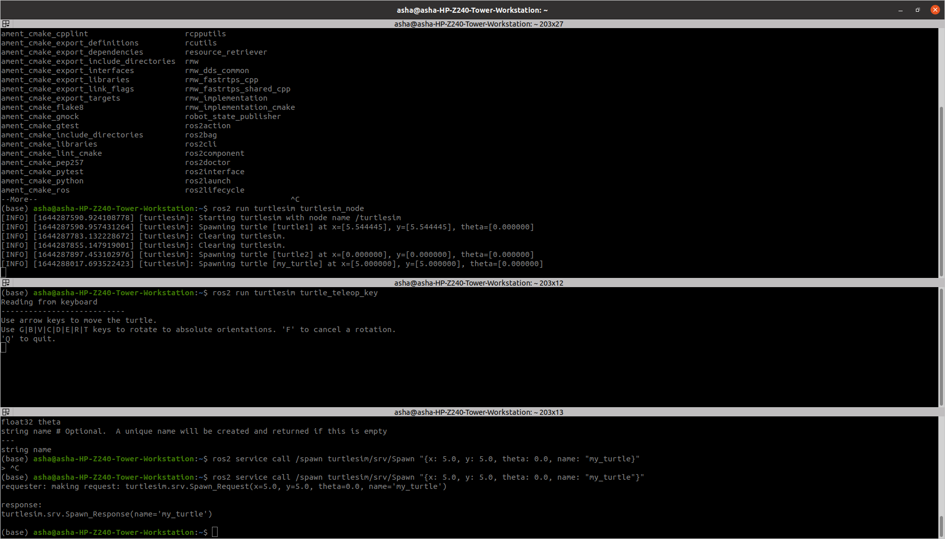

ROS2 interfaces:

<https://github.com/ros2/example_interfaces>

<https://github.com/ros2/common_interfaces>

You will use 3 nodes:

* The turtlesim_node from the turtlesim package
* A custom node to control the turtle (named “turtle1”) which is already existing in the turtlesim_node. This node can be called turtle_controller.
* A custom node to spawn turtles on the window. This node can be called turtle_spawner.

**Execute in Terminal #1**

cd ~/ros2_ws/src/my_package/my_package

**Execute in Terminal #2**

touch turtle_controller.py

chmod + turtle_controller.py

Open src with Visual Studio Application

Enter the code in turtle_controller.py

#!/usr/bin/env python3

import rclpy

from rclpy.node import Node

from turtlesim.msg import Pose

from geometry_msgs.msg import Twist

import math

class TurtleControllerNode(Node):

def __init__(self):

super().__init__("turtle_controller")

self.target_x = 8.0

self.target_y = 4.0

self.pose_ = None

self.cmd_vel_publisher_ = self.create_publisher(Twist, "turtle1/cmd_vel", 10)

self.pose_subscriber_ = self.create_subscription(Pose, "turtle1/pose", self.callback_turtle_pose, 10)

self.control_loop_timer_ = self.create_timer(0.01, self.control_loop)

def callback_turtle_pose(self,msg):

self.pose_ = msg

def control_loop(self):

if self.pose_ == None:

return

dist_x = self.target_x - self.pose_.x

dist_y = self.target_y - self.pose_.y

distance = math.sqrt(dist_x * dist_x + dist_y * dist_y)

msg = Twist()

if distance > 0.5:

msg.linear.x = distance

goal_theta = math.atan2(dist_y, dist_x)

diff = goal_theta - self.pose_.theta

if diff > math.pi:

diff -= 2*math.pi

elif diff < -math.pi:

diff += 2*math.pi

msg.angular.z = diff

else:

msg.linear.x = 0.0

msg.angular.z = 0.0

self.cmd_vel_publisher_.publish(msg)

def main(args=None):

rclpy.init(args=args)

node = TurtleControllerNode()

rclpy.spin(node)

rclpy.shutdown()

if __name__ == "__main__":

main()

**Modify entry_points setup.py as**

entry_points={

'console_scripts': [

'sample = my_package.sample:main',

'robot_publisher = my_package.robot_publisher:main',

'robot_subscriber = my_package.robot_subscriber:main',

'turtlesim_controller = my_package.turtle_controller:main'

],

},

)

**Modify he package.xml as**

<depend>rclpy</depend>

<depend>example_interfaces</depend>

<depend>my_robot_interface</depend>

<depend>turtlesim</depend>

**Execute in Terminal #1**

ros2 run turtlesim turtlesim_node

**Execute in Terminal #2**

colcon build --packages-select my_package --symlink-install

**Execute in Terminal #3**

ros2 run my_package turtlesim_controller

**Execute in Terminal #4**

ros2 service list

ros2 service type /spawn

ros2 interface show turtlesim/srv/Spawn

**Execute in Terminal #1**

cd ros2_ws/my_robot_interface/srv

touch MoveLocation.srv

Edit MoveLocation.srv

float32 loc_x

float32 loc_y

---

float32 distance

Change CmakeLists.txt as

rosidl_generate_interfaces(my_robot_interface

"msg/ManufactureDate.msg"

"srv/SetDate.srv"

"srv/MoveLocation.srv"

)

**Execute in Terminal #1**

cd ~/ros2_ws

colcon build –packages-select my_robot_interface

Send the service request to find the distance between current location and new location.

#!/usr/bin/env python3

import rclpy

from rclpy.node import Node

from turtlesim.msg import Pose

from geometry_msgs.msg import Twist

from my_robot_interface.srv import MoveLocation

import math

class TurtleControllerNode(Node):

def __init__(self):

super().__init__("turtle_controller")

self.target_x = 9.0

self.target_y = 9.0

self.pose_ = None

self.cmd_vel_publisher_ = self.create_publisher(Twist, "turtle1/cmd_vel", 10)

self.pose_subscriber_ = self.create_subscription(Pose, "turtle1/pose", self.callback_turtle_pose, 10)

self.control_loop_timer_ = self.create_timer(0.01, self.control_loop)

self.servce_ = self.create_service(MoveLocation, "move_location", self.callback_get_distance)

def callback_turtle_pose(self,msg):

self.pose_ = msg

def control_loop(self):

if self.pose_ == None:

return

dist_x = self.target_x - self.pose_.x

dist_y = self.target_y - self.pose_.y

distance = math.sqrt(dist_x * dist_x + dist_y * dist_y)

msg = Twist()

if distance > 0.5:

msg.linear.x = distance

goal_theta = math.atan2(dist_y, dist_x)

diff = goal_theta - self.pose_.theta

if diff > math.pi:

diff -= 2*math.pi

elif diff < -math.pi:

diff += 2*math.pi

msg.angular.z = diff

else:

msg.linear.x = 0.0

msg.angular.z = 0.0

self.cmd_vel_publisher_.publish(msg)

def callback_get_distance(self, request, response):

x = request.loc_x - self.pose_.x

y = request.loc_y - self.pose_.y

response.distance = math.sqrt(x * x + y * y)

return response

def main(args=None):

rclpy.init(args=args)

node = TurtleControllerNode()

rclpy.spin(node)

rclpy.shutdown()

if __name__ == "__main__":

main()

**Execute in Terminal #1**

colcon build –packages-select my_package

**Execute in Terminal #2**

ros2 run turtlesim turtlesim_node

**Execute in Terminal #3**

ros2 run my_package turtlesim_controller

**Execute in Terminal #1**

ros2 service call /move_location my_robot_interface/srv/MoveLocation "{loc_x: 5.0, loc_y: 5.0}"

**Exercise2: Create two new files named movement_server.py and movement_client.py.**

1. Create a directory named **srv** inside my_robot_interface package
2. Inside this directory, create a file named **MyCustomServiceMessage**.srv

string move # Signal to define movement

# "Turn right" to make the robot turn in right direction.

# "Turn left" to make the robot turn in left direction.

# "Stop" to make the robot stop the movement.

**---**

bool success

1. Modify CMakeLists.txt file
2. Modify package.xml file
3. Compile and source
4. Use in code

ros2 interface show my_robot_interface**/**srv**/**MyCustomServiceMessage

Action Server – Action Client Nodes

**Execute in Terminal #1**

cd ~/ros2_ws/src/my_robot_interface

mkdir action

touch Navigate2D.action

#Goal

int32 secs

---

#Result

string status

---

#Feedback

string feedback

package.xml

<depend>rclcpp</depend>

<depend>std_msgs</depend>

<depend>action_msgs</depend>

CMakeLists.txt

rosidl_generate_interfaces(my_robot_interface

"msg/ManufactureDate.msg"

"srv/SetDate.srv"

"srv/MoveLocation.srv"

"action/Navigate2D.action"

)

**Execute in Terminal #1**

colcon build –packages-select my_robot_interface

**Execute in Terminal #1**

cd ~/ros2_ws/src/my_package/my_package

touch action_client.py

chmod +x action_client.py

import rclpy

from rclpy.action import ActionClient

from rclpy.node import Node

from rclpy.executors import MultiThreadedExecutor

from my_robot_interface.action import Navigate2D

class MyActionClient(Node):

def __init__(self):

super().__init__('action_client')

self._action_client = ActionClient(self, Navigate2D, "navigate")

def send_goal(self, secs):

goal_msg = Navigate2D.Goal()

goal_msg.secs = secs

self._action_client.wait_for_server()

self._send_goal_future = self._action_client.send_goal_async(goal_msg, self.feedback_callback)

self._send_goal_future.add_done_callback(self.goal_response_callback)

def goal_response_callback(self, future):

goal_handle = future.result()

if not goal_handle.accepted:

self.get_logger().info('Goal rejected')

return

self.get_logger().info('Goal accepted')

self._get_result_future = goal_handle.get_result_async()

self._get_result_future.add_done_callback(self.get_result_callback)

def get_result_callback(self, future):

result = future.result().result

self.get_logger().info('Result: {0}'.format(result.status))

rclpy.shutdown()

def feedback_callback(self, feedback_msg):

feedback = feedback_msg.feedback

self.get_logger().info('Received feedback: {0}'.format(feedback.feedback))

def main(args=None):

rclpy.init(args=args)

action_client = MyActionClient()

future = action_client.send_goal(5)

executor = MultiThreadedExecutor()

rclpy.spin(action_client, executor=executor)

if __name__ == '__main__':

main()

**Execute in Terminal #1**

cd ~/ros2_ws/src/my_package/my_package

touch action_server.py

chmod +x action_server.py

Edit the file action_server.py

#!/usr/bin/env python3

import rclpy

from rclpy.node import Node

from turtlesim.msg import Pose

from geometry_msgs.msg import Twist

from rclpy.action import ActionServer

import time

from my_robot_interface.action import Navigate2D

class NavigateAction(Node):

def __init__(self):

super().__init__("action_server")

self.action_server_ = ActionServer(

self, Navigate2D, "navigate", self.navigate_callback)

self.cmd = Twist()

self.publisher_ = self.create_publisher(Twist, "turtle1/cmd_vel", 10)

def navigate_callback(self, goal_handle):

self.get_logger().info('Executing goal...')

feedback_msg = Navigate2D.Feedback()

feedback_msg.feedback = "Moving to the left ..."

for i in range(1, goal_handle.request.secs):

self.get_logger().info(feedback_msg.feedback)

goal_handle.publish_feedback(feedback_msg)

self.cmd.linear.x = 0.3

self.cmd.angular.z = 0.3

self.publisher_.publish(self.cmd)

time.sleep(1)

goal_handle.succeed()

self.cmd.linear.x = 0.0

self.cmd.angular.z = 0.0

self.publisher_.publish(self.cmd)

feedback_msg.feedback = "Finished action server. Robot moved during 5 seconds"

result = Navigate2D.Result()

result.status = feedback_msg.feedback

return result

def main(args=None):

rclpy.init(args=args)

node = NavigateAction()

rclpy.spin(node)

rclpy.shutdown()

if __name__ == "__main__":

main()

Edit CmakeLists.txt

entry_points={

'console_scripts': [

'sample = my_package.sample:main',

'robot_publisher = my_package.robot_publisher:main',

'robot_subscriber = my_package.robot_subscriber:main',

'add_two_int_server = my_package.add_two_int_server:main',

'add_two_ints_client = my_package.add_two_ints_client:main',

'turtlesim_controller = my_package.turtle_controller:main',

'action_client = my_package.action_client:main',

'action_server = my_package.action_server:main'

],

**Execute in Terminal #1**

ros2 run turtlesim turtlesim_node

**Execute in Terminal #2**

ros2 run my_package action_client

**Execute in Terminal #3**

ros2 run my_package action_server